**Chapter 4**

1. Answer is A

The polymers do not crystalline easily because of the chains,or parts of chains that are not in the crystals have no order to the arrangement of their chains.so polymers are do not crystalline bacuse of long chain molecules.

2. **Amorphous polymers** **Crystalline polymers**

i) do not have uniformaly packed molecules i) have uniformly packed material

ii) do not have sharp melting point ii) have sharp melting point

iii) transparent iii) opaque or translucent

iv) low shrinkage iv) high shrinkage

v) poor chemical resistance v)good chemical resistance

vi) soft vi) hard

vii) low energy vii) high energy

5) thermosetting polymers are made up from long chain of molecules that are cross linked they have very rigid structure.

**Thermoplastics Thermosetting**

i) can be synchronised by the process called i) can be symchronised by condensation polymers

addition polymerisation

ii) it is processessed by injection moulding,extrusion ii) can be processed by compression moulding,reaction

process,blow moulding injection moulding

iii) secondary bonds between molecular chains iii) there are primary bonds between molecular chains and

iv) low melting point and low strenthile stress held together by cross-links

iv) high melting point and strenthile stress

v) lower in molecular weight compaed to thermosetting v) high molecular weight

7) C ( polyvinylidene chloride ) If all the methyl groups lie on the same side of the chain, the polymer is called **isotactic**. If the methyl groups alternate in a regular fashion from one side of the chain to the other, the polymer is **syndiotactic**.

15) option e Is correct

increase crystallinity in a vinyl polymer by change the tacticity from atactic to syndiotactic , stretch , anneal it , solidify from melt at a slow rate .

16) option A is correct (isotactic polystyrene

**Chapter 5**

9. b contracts.Polymers like rubber shrink on heating as their molecular chains curl up, this occurs because of the unusual polymer structure of rubber. When the long chains get hotter and vibrate, they actually shorten, causing the material to contract..

11.d the crystalline melting point is not affected by the presence of solvents. The polymer melting point Tm is increased if the double bonds, aromatic groups, bulky or large side groups are present in the polymer chain, because they restrict the flexibility of the chain. The branching of chains causes the reduction of melting point, as defects are produced because of the branching.

Crystallinity can range from 0 percent (entirely amorphous) to 100 percent (entirely crystalline), but most polymers fall somewhere between those extremes. As a result, amorphous polymers don't have a melting point — they have a glass transition temperature, or Tg

The glass transition is not considered a first-order phase transition, but a kinetic phenomenon or a second-order transition. The glass transition is a temperature range over which the amorphous regions change from a brittle glassy state to a flexible rubbery state as they are heated.

12. a. polypropylene has the lowest Tg .

Insertion of bulky, inflexible side group increases Tg of material due to decrease in mobility, as in case 2 or second structure or polymer.

13.PVC consists of polar molecules which are attracted to each other by dipole-dipole interactions due to electrostatic attractions of a chlorine atom in one molecule to a hydrogen atom in another atom

15. b free volume effects due to flexible side chains Chemical cross-linking - Increase in cross-linking decreases mobility leads to decrease in free volume and increase in Tg.

18 c increase in Tg and Tm , the presence of bulky pendant group, such as a benzene ring, can restrict rotational freedom, leading to higher glass transition temperature. The polymer melting point Tm is increased if the double bonds, aromatic groups, bulky or large side groups are present in the polymer chain, because they restrict the flexibility of the chain.

20.Chain flexibility is one of the important factor, which affects Tg.

Intrinsic chain flexibility is determined by the nature of polymer backbone and groups

directly attached to it. Aliphatic C-C and C-O bonds show quite flexibility while

introduction of ringed structures causes stiffening of chain. Stiffening of chain causes

increase in glass transition temperature therefore glass transition temperature of

polyethylene terephthalate is higher than their aliphatic counterparts. Bulky group

attached to polymer backbone also reduces flexibility of chain backbone therefore

polypropylene has higher Tg than polyethylene. Polytetrafluoroethylene has high Tg than

polyethylene as size of fluorine atom is large and it requires the molecule to take zig-zag

configuration in which fluorine atoms are packed tightly and chain gets stiffened.

Introduction of double bond also causes stiffening of chain alongwith this it may increase

flexibility of adjacent bonds therefore it causes decrease in Tg and explains the low Tg of

cis-1,4-polybutadiene is lower than polyethylene.

**Chapter 6**

Answer to Q3

a) Atactic PS is a brittle polymer

b) HDPE is a plastic

c) copolymer of styrene and butadiene is SBR, which is an elastomer

Please find the attached figure.

**4**

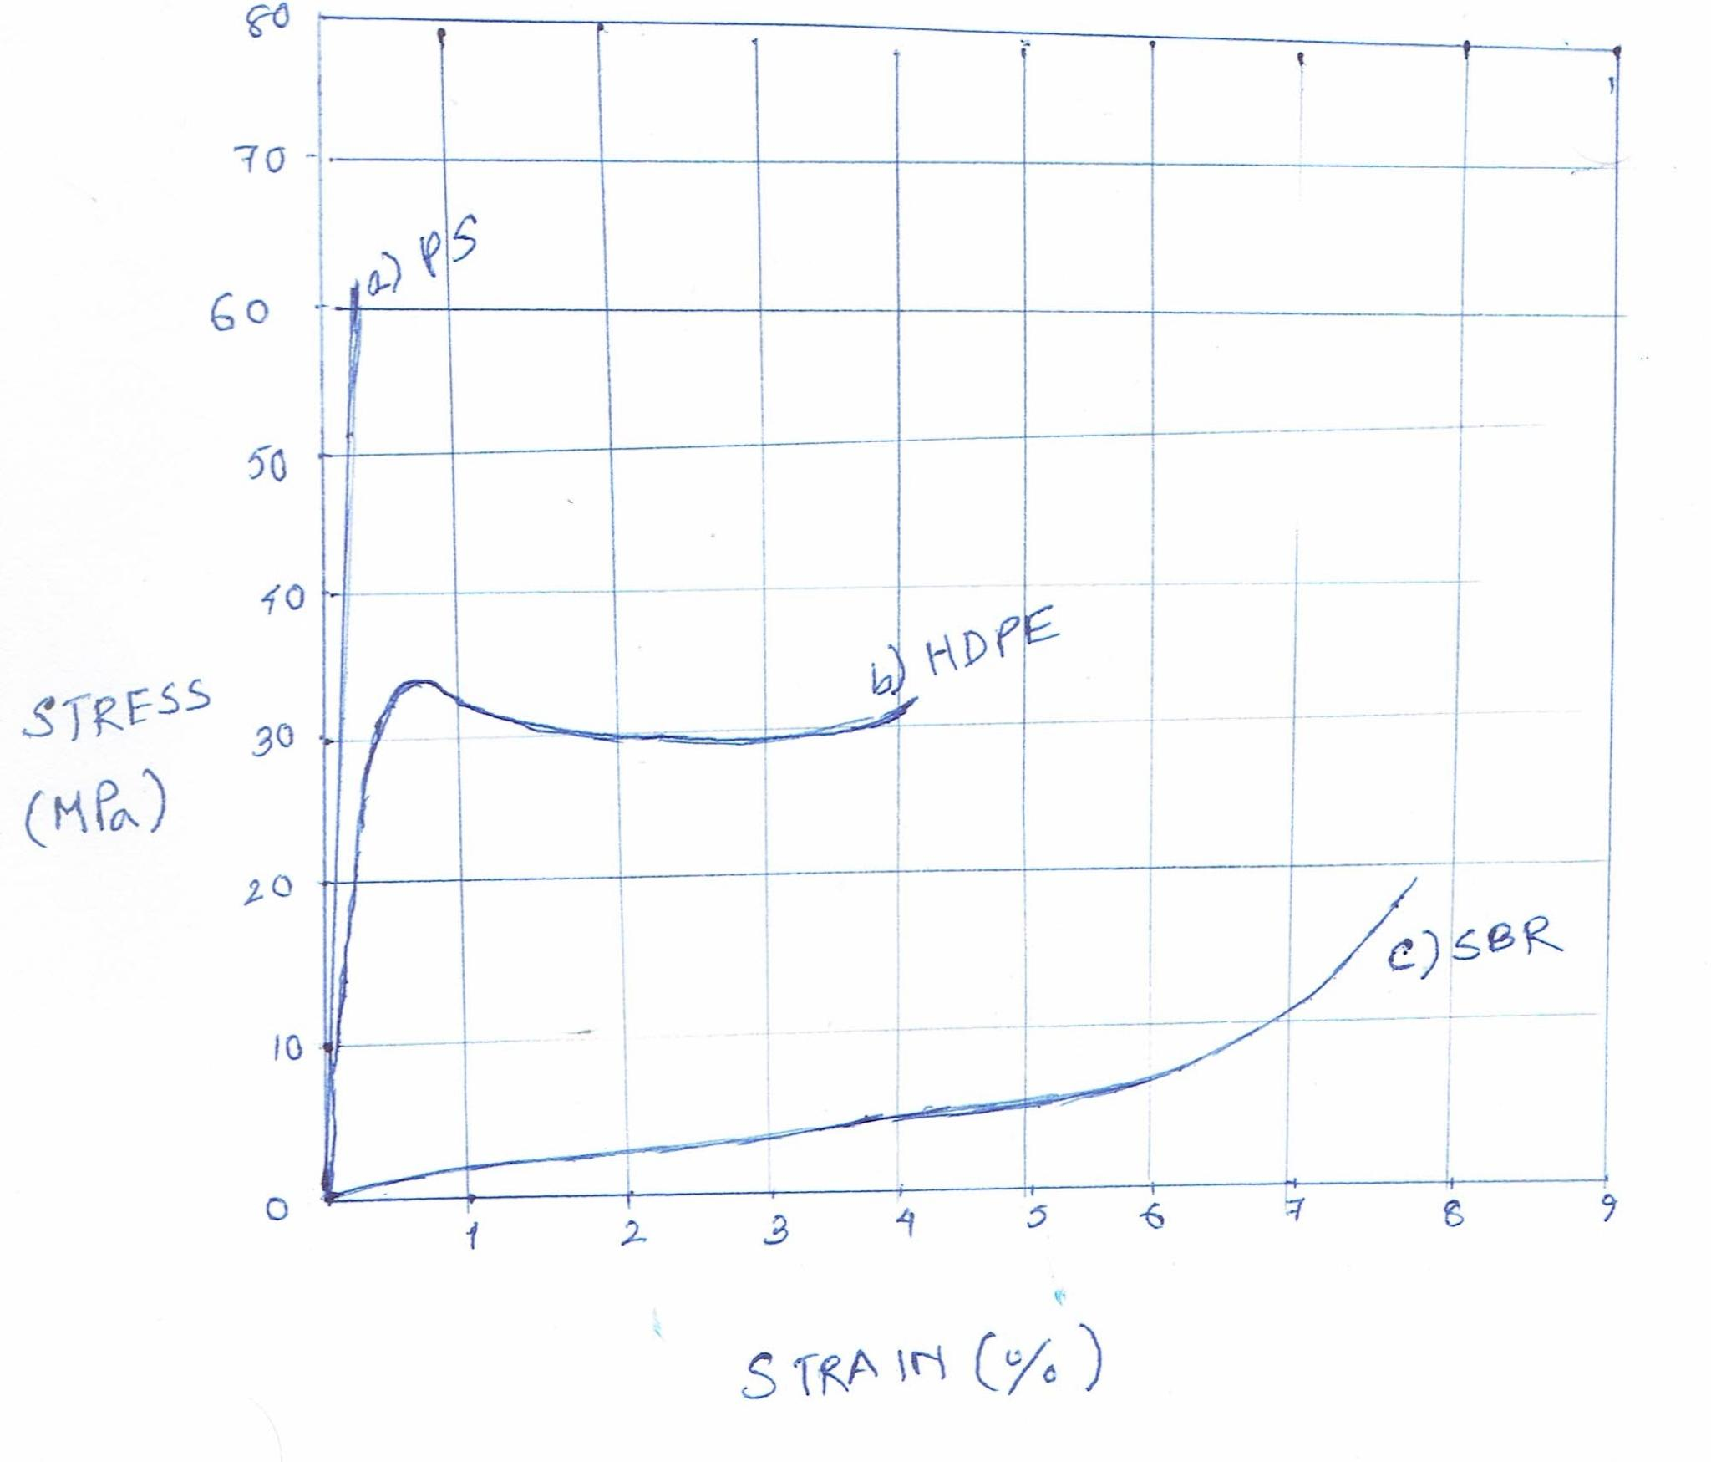

**CHapter 7**

1.The graph is given below where Tg is the glass transition temperature.

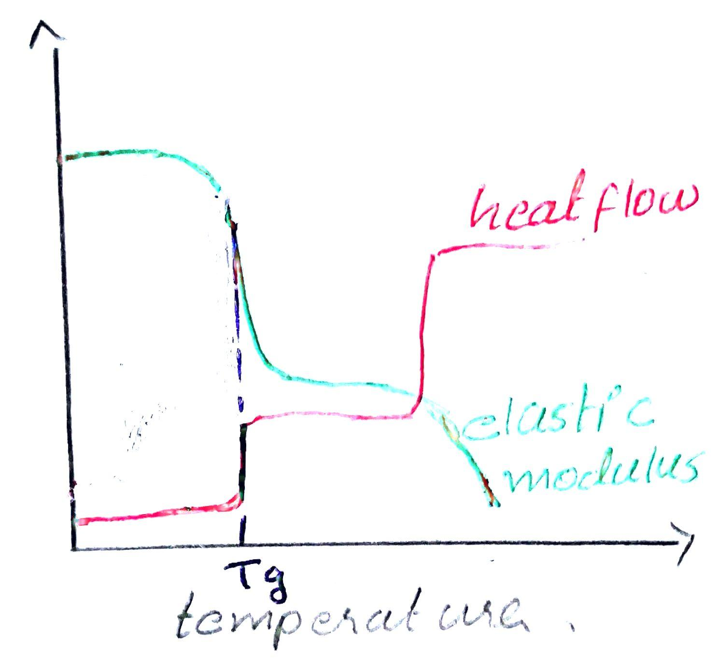5.

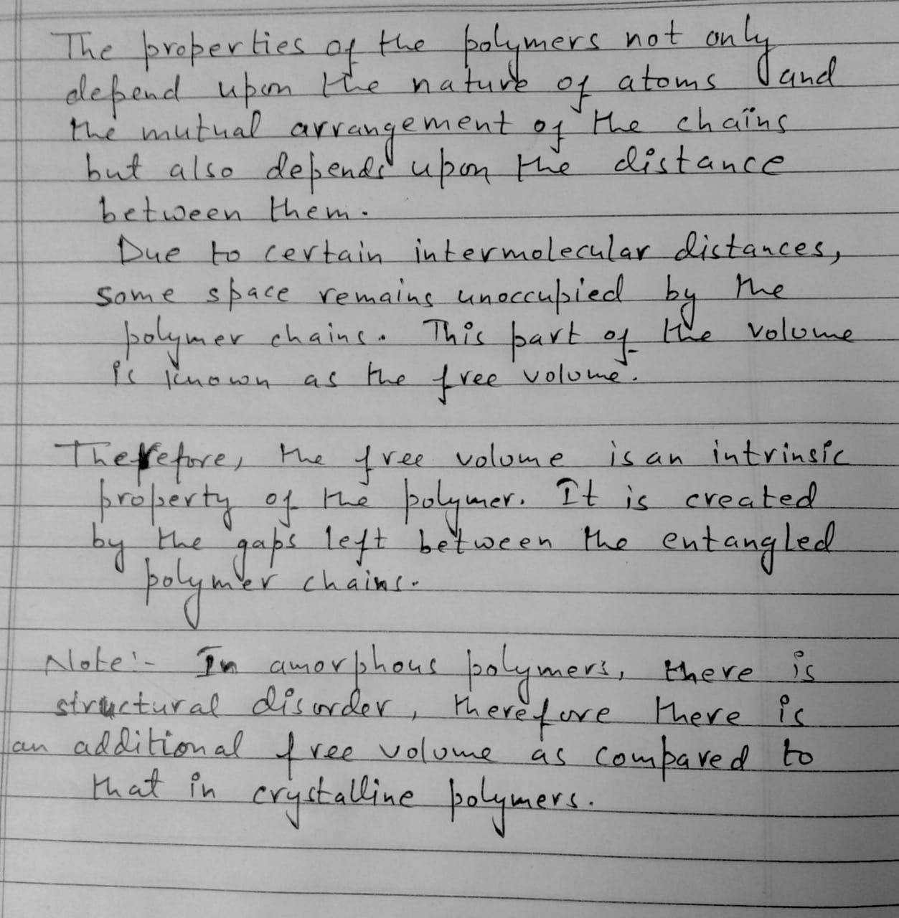

7. Volume will increase with temperature

Here the option b will be the answer because if poly propylene homopolymer is alone is present then graph c will be the behaviour. And the polymer is polylactic acid then it will behave like option a but here the poly propylene is with spherulitic then they behave as option b.

**11b**

**Question 16**

*) DSC = Differential Scanning Calorimetry => This technique measures the difference in the amount of heat required to increase the temperature of a sample and a reference (both are maintained at the same temperature during the experiment).

*) The following thermal properties could be obtained from aDSC analysis: a) Glass transition temperature => this is the temperature where an amorphous material (or a semicriytalline material) changes from a glassy state to a rubbery state b) Melting temperature => this is the temperature where a solid material is converted into ir liquid form. It is only observed in crystalline materials. c) Heat of fusion => this is the energy required to change a specific amount of a compound from its solid form to its liquid form d) Thermal history => it refers to the history of temperature changes which a material undergoes.

**Manashu javoblar 16 , 20 ,24 ga javob boladi**